How to Pay Fee through SB collect?
Step 1:
Search “SBI Collect” in Google. Click on State Bank Collect.
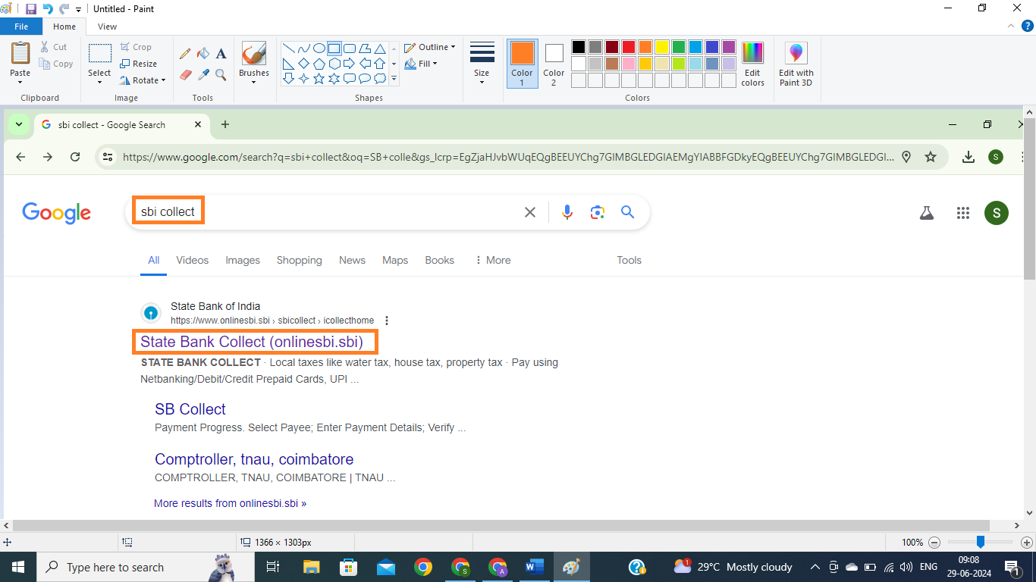
Step 2:
Now Click on “Educational Institutions”
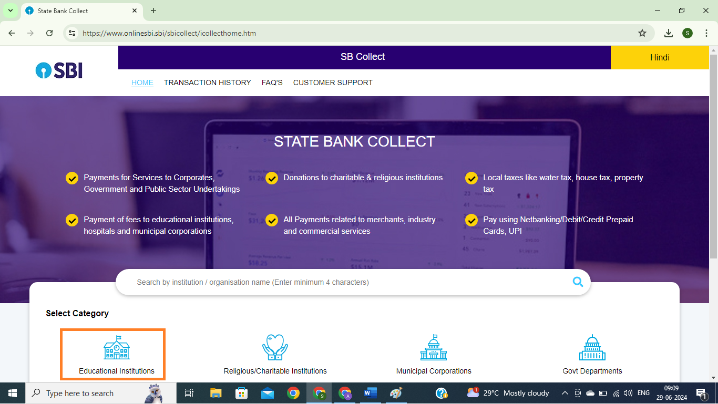
Step 3: In the search box type “ATOMIC ENERGY EDUCATION SOCIETY”, Select “Maharashtra” from state list, Then Click on “ATOMIC ENERGY EDUCATION SOCIETY” appearing under Name of Educational Institution
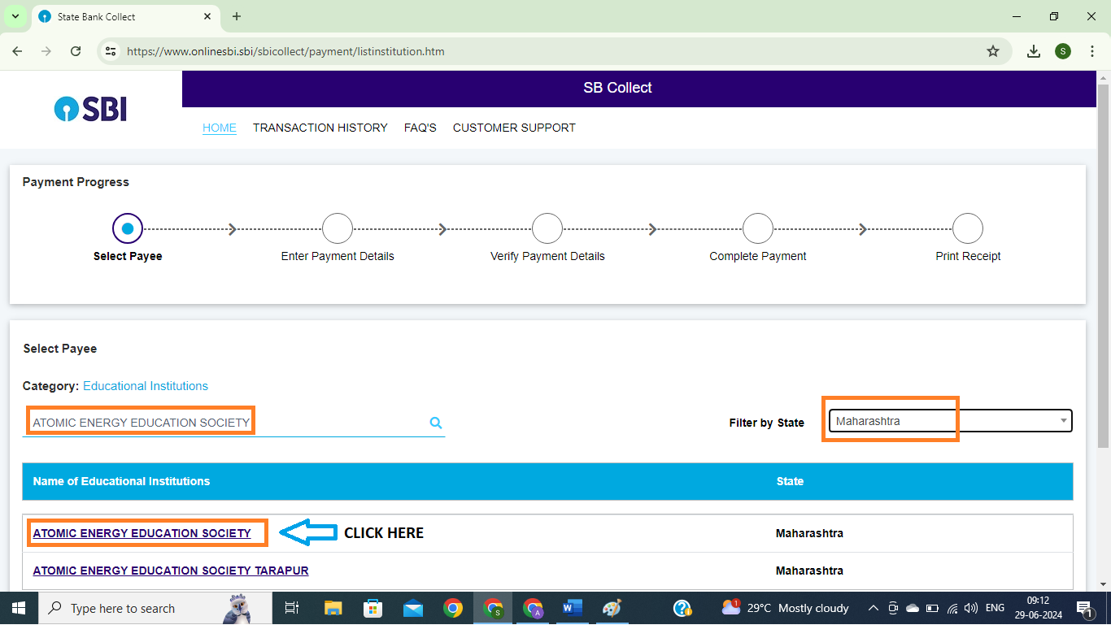
Step 4: Under Payment Category Please select “AECS3-School Fee- 12 Months” OR “AECS3-School Fee- 6 Months”
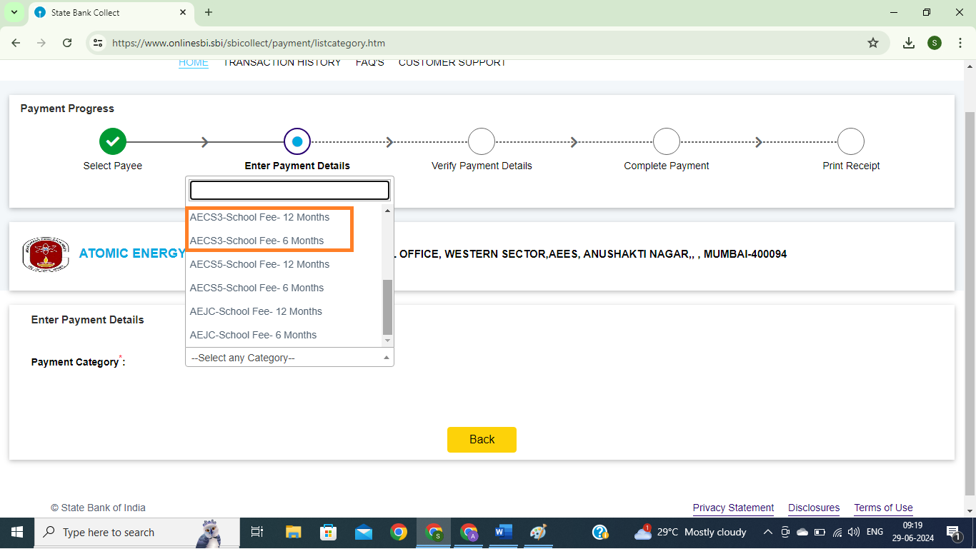

Step 5:
Enter the UID of the student as uploaded in the school website on 29/06/2024. Click on “FETCH PAYMENT DETAILS”
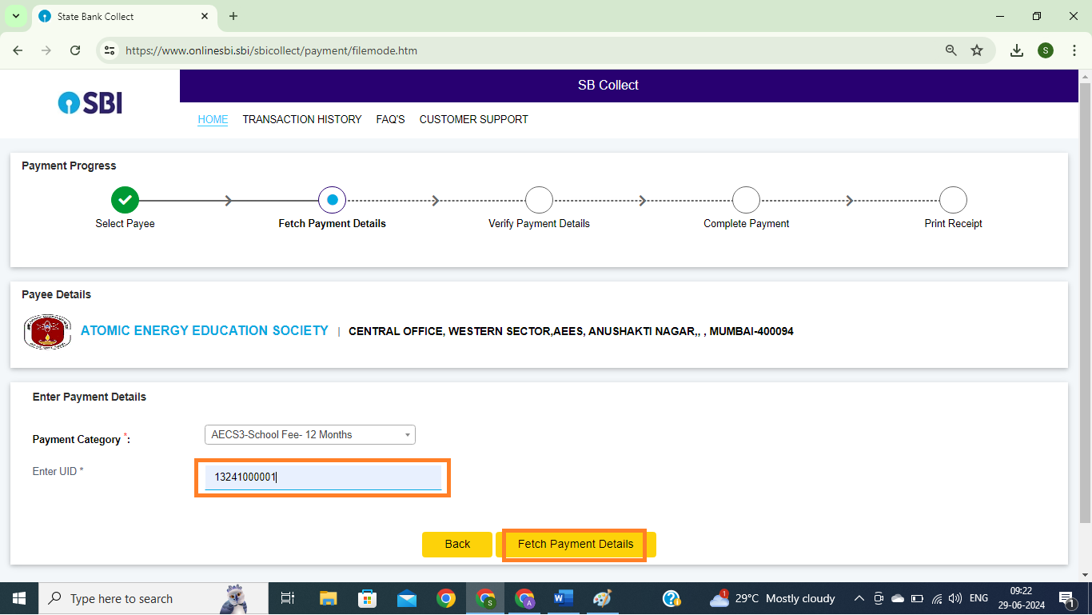
Step 6:
Details of the student will appear on the next page. Please see the details. Verify the same. Below the student’s details, enter details of the person making the payment,
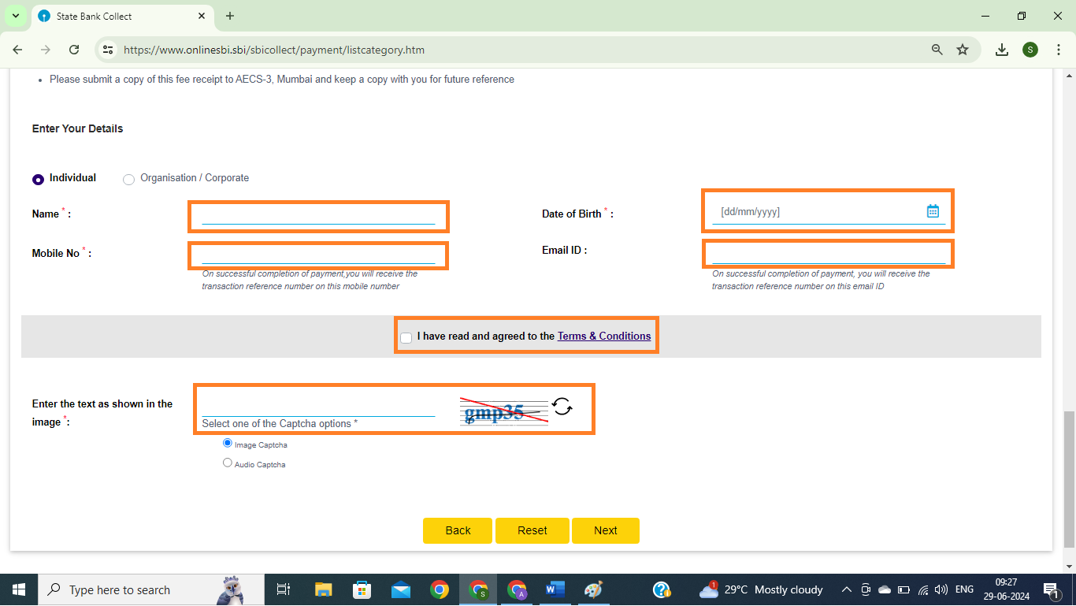
Click on NEXT and go to the next page
Step-6: Total fee payable will be shown on top of the page. Scroll down and
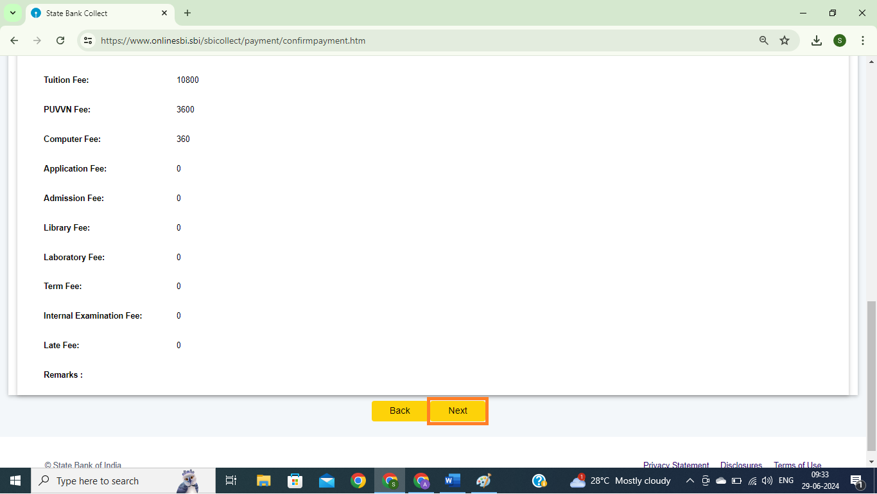

Step-7: Now select your payment mode and make the payment
